**PERT Solver User Guide**

1. **GETTING STARTED**

The PERT Solver program is intended to automatically solve PERT (Project Evaluation and Review Technique) problems supplied by the user. The solutions provided by PERT Solver contain the following information about the problem:

1. Detailed scheduling information for all activities.
2. Identification of critical path activities.
3. Minimum resources required to complete the project
4. Activity schedules requiring the minimum number of resources.
5. PERT diagram image showing all activities, the critical path, and scheduling information.

**1.1 Installation**

To make installation of the program as simple as possible, all of its dependencies have been included with the program itself. All that is needed to install the program is to extract the PERT_Solver.zip file to a location of the user’s choice. For convenience, it is also recommended to make a shortcut to the PERT_Solver.exe file in the extracted folder, and place the shortcut on your desktop.

**1.2 Running the program**

If you have created a shortcut during installation, you can run the program by simply double clicking the shortcut. If not, you will need to navigate to the location where PERT Solver was installed, and double click the PERT_Solver.exe file.

1. **PROGRAM USAGE**

The user interface of PERT Solver is very much LINDO inspired and should look familiar to users of LINDO. There is a menu bar at the top of the program window where you can access various program features, and the rest of the window is the problem editor.

**2.1 File menu**

The following items are available from the File menu:

**New** – Closes the current problem and clears the problem editor.

**Open** – Loads the contents of a problem file into the problem editor.

**Save** – Saves the contents of the problem editor to the current file.

**Save As** - Saves the contents of the problem editor to a specific file.

**Exit** – Closes the PERT Solver program.

**2.2 Solve menu**

The following items are available from the Solve menu:

**Solve** – Attempts to solve the problem currently in the problem editor.

**2.3 Problem editor**

The problem editor is where you can view and edit opened problems, or write up a new problem from scratch.

1. **PROBLEM FORMATTING**

Problems in the problem editor need to be formatted in a specific way for PERT Solver to understand them. If they are not formatted correctly PERT Solver will fail to solve them and present an error explaining where the problem is. Lines of text starting with a ‘!’ character will be ignored when parsing the problem, so you can use these to create comments in the problem. Empty lines of text are also ignored by the parser.

Any line of text that is not empty and does not start with ‘!’ is considered an activity, and it must follow the format for activities. All activities must have a name, a duration, a resource requirement, and optionally the names of prerequisite activities. Each of these elements is to be separated by a comma and written in the order shown below.

**Name, Duration, Resources, Prerequisite_1, Prerequisite_2, … , Prerequisite_n**

All prerequisite activities must be defined before the activity they appear as prerequisites in.

1. **INTERPRETING RESULTS**

If PERT Solver succeeds in solving the problem presented to it, a second window will pop up showing the results. The results window will show a listing of all milestones, the activities leading to and from each milestone, a list of activities on the critical path, the minimum required resources to complete the project, and finally at list of activity schedules that achieve the minimum resource requirement. You will also be asked if you would like PERT Solver to produce a PERT diagram for the solution.

**4.1 Labels**

The output in the results window and in the PERT diagram uses short forms for the names of scheduling information. This in an effort to reduce the amount of text the user must read and to reduce clutter on the PERT diagram. The legend below provides the short form for each piece of scheduling information and the corresponding full names.

**TE** – Earliest start time of a milestone.

**TL** – Latest start time of a milestone.

**S** – Slack time of a milestone or an activity.

**D** – Duration of an activity.

**L** – Labour or resources required to complete an activity.

**FS** – Free slack time of an activity.

1. **EXAMPLES**

The figures in this section show examples of input provided PERT Solver and the outputs it produces.

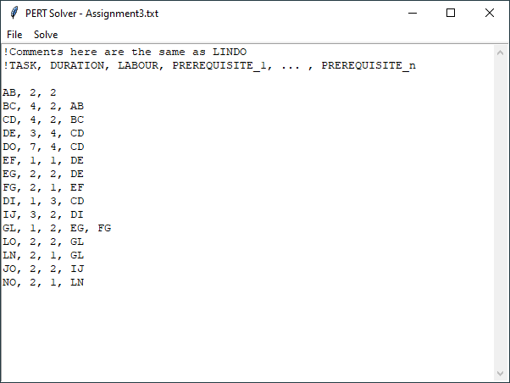

Figure 1: Entering a problem into PERT Solver

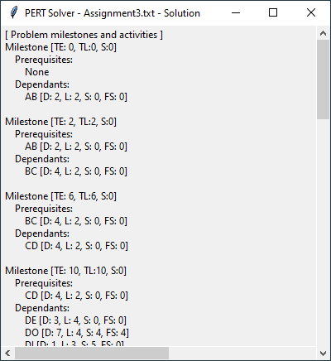

Figure 2: Solution showing some milestones and activities.

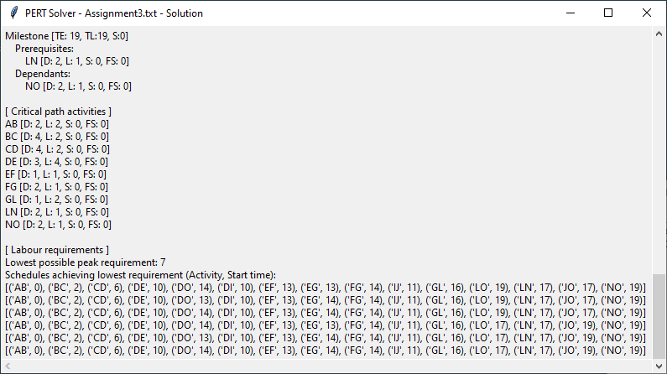

Figure 3: Solution showing critical path, minimum resources, and activity schedules.

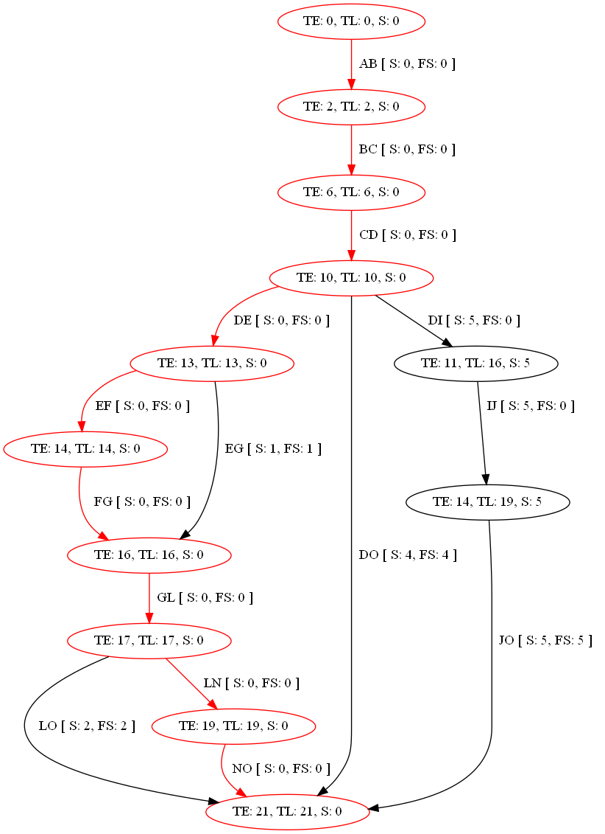

Figure 4: PERT diagram produced by PERT Solver (Critical path in red)